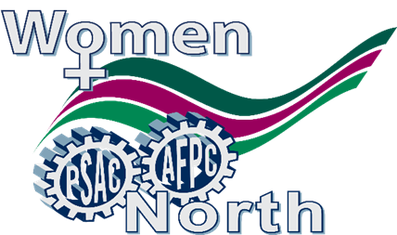

**PSAC NT REGIONAL WOMEN’S COMMITTEE**

**SPECIAL GENERAL MEETING**

**JANUARY 28, 2020 @ 5:30 P.M.**

**PSAC Regional Office Boardroom – North Star Building**

Suite 201, 4910 – 53rd Street, Yellowknife

**Out of town members are invited to participate by teleconference.** **Please dial** 1 (844) 259-7596 and when prompted please enter the conference code followed by the number sign: 66553814#

**AGENDA**:

1. Call to Order
2. Roll Call
3. Adoption of Agenda
4. Adoption of the last meeting minutes
5. Reports
6. Old Business
   * Sanitary napkins project update
   * Adoption – Meeting Minutes, September 24, 2019
7. New Business
   * International Women’s Day
   * Movie night – March 2020
   * Spring Trade Show - 2020
8. Round Table
9. Adjournment

Should you require any further information please contact Geraldine Penny, Chair, NT RWC via email: geraldinepenney@hotmail.ca or Marija Babic, Regional Representative via email: babicm@psac-afpc.com or the Yellowknife Regional Office by phone at 867.873.5670 or toll free at 1.800.661.0870

**Child Care will be provided as per the Family Care Policy.**

**All PSAC women are welcome and encouraged to attend**