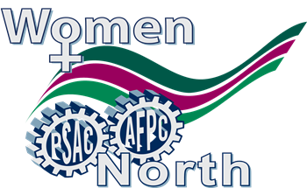

NWT Regional Women's
Committee Meeting

Tuesday, May 19th, 2018, 5:30 p.m.

PSAC Boardroom #201
North Star Building
4910 - 53rd Street, Yellowknife, NT
or
Call–In Toll Free @ 1-866-234-6693 enter 6138582367#

Agenda
- Call to order
- Adopt Agenda
3) Adopt Minutes
4) Chair Report
5) Old Business
6) New Business
7) Adjournment

For more information contact Geraldine Penney, Chair of the NWT Regional Women’s Committee at geraldinepenney@hotmail.ca, or Kim Bailey, A/Regional Representative at BaileyK@psac-afpc.com, (867) 445 -3319 or the Yellowknife Regional Office 873-5670 ext 1008

