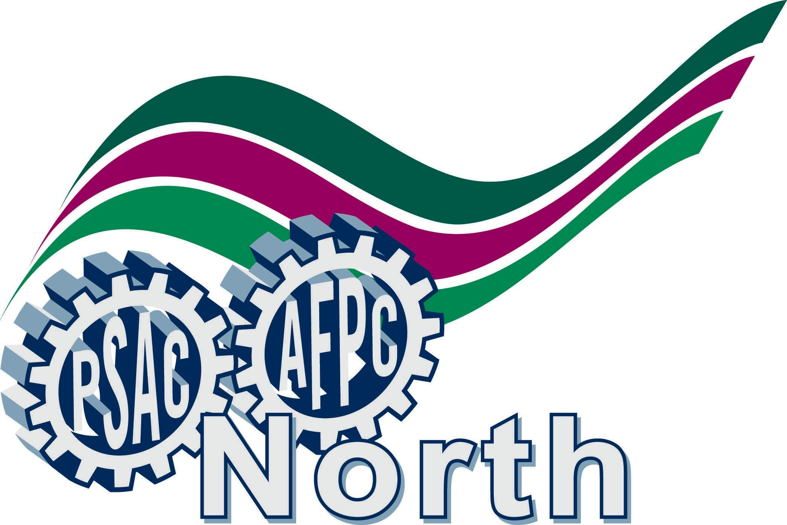
Bargaining Communiqué
to PSAC / NEU / Local N006 Members
City of Iqaluit workers deserve better

February 2nd, 2016

The City of Iqaluit bargaining team met with the Employer’s team to negotiate a new collective agreement on January 15-20, 2016.

We have exchanged proposals and from the beginning the Employer signalled to us that we, the members, were going to have to share some responsibilities.

The Union’s bargaining team recognizes that there is a deficit in the City’s budget, with disputed numbers. The Union is prepared to work with the Employer to find other means to alleviate its financial situation, without resorting to lay-offs and contracting-out of services that our members have been doing with respect, diligence and pride.

We also introduced proposals that we believe will address what you, our members, have asked for. We came to the table with the intent to bargain in good faith and reach a settlement through meaningful discussions. We indicated that we were interested in negotiating improvements, not concessions or clawbacks of benefits that we have currently in our collective agreement.

The Union bargaining team feels that the Employer’s proposals are not respectful and fair to the membership. Many union members are also long-standing members of the community, and have provided valuable public services to their community. As such, they should be treated as valued individuals, not as a bottom line number.

We are scheduled to meet again with the Employer in February 2016. If you have any questions, please contact your bargaining team members. Stand tall and support your bargaining team!

In Solidarity,

Local N006 Bargaining Team:
Holmann Richard, Negotiator Bill Fennell, President, NEU
Paul Clow, member Jack Bourassa, PSAC REVP N.
Bob Brouillet, member Kyle Nowlan, member
Tracey Oram, member

